

SCS 3250-041 FOUNDATIONS OF DATA SCIENCE

ANALYSIS REPORT: GLOBAL SUICIDE TRENDS

Apr, 14 2020

GROUP 1

Ekenedilichukwu Ani

Prabhdeep Jammu

Daniel Romney

Ulker Tas

Concetta Volpe

**X. SUICIDE TRENDS COMPARISON – CANADA vs GLOBAL**

In this section, the suicide trends experienced in Canada vs Global are reviewed in details. For this analysis, the first step is to separate dataset into two Dataframes as shown below:

Dataset #1: Canada only

data_Canada=master_good.loc[master_good['country']=='Canada']

Dataset #2: All countries excluding Canada

data_Global=master_good.loc[master_good['country']!='Canada']

**x.1 Suicide rates comparison for different age groups – Canada vs Global**

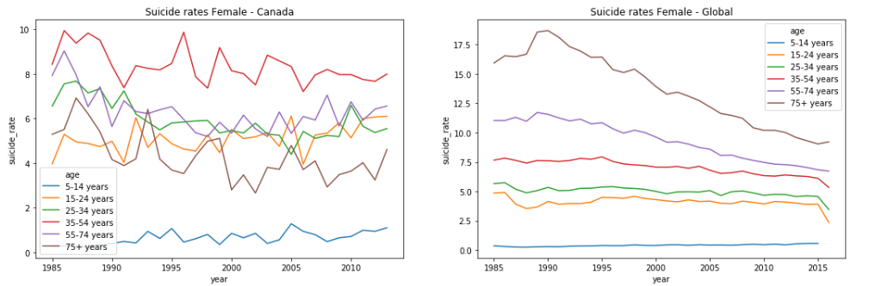**Figure x.1 Suicide trends for Females – Canada vs Global**

As shown in Figure x.1, Female suicide rates have been the **highest** for the age group **35-54** **years** consistently since 1985 whereas globally, highest suicide rate is experienced for the age Group of 75+ years. Different than global trends, females in Canada who age equal to or more than 75 years end their life by committing suicide less often in comparison to other adult groups (all excluding the age group 5-14 years). In Canada, the age group of 75+ years experiences the **lowest** suicide rates among female adults. Globally, we see that all age groups excluding 5-14 years show a downward trend since the beginning of 90s in terms of suicide rates. Similar to the global trends, the age group of 5-14 years shows an increasing suicide rate trend for females in Canada. Different than trends in Canada, global trends show that suicide rates increase as the age goes up for females. The same conclusion is also valid for males as shown in Figure x.2 for cumulative suicide rates of all countries excl. Canada.

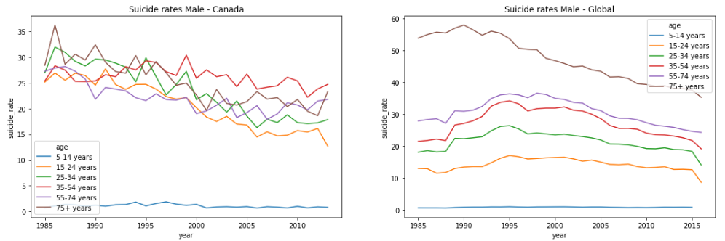

**Figure x.2 Suicide trends for Males – Canada vs Global**

Similar to female trends, Figure x.2 shows that Male suicide rates have been the **highest** for the age group **35-54 years** since early 2000s. The graph shows that there is steady decrease in suicide rates for Canadian males aging more than 75. One Canadian trend that overlaps with the global trend is that there is again a significant difference between male and female suicide rates overall and for all age groups, males experience significantly higher suicide rates in comparison to females.

Statistics Canada analysis confirms that it is a persistent trend in Canada for many years to see significantly higher suicide rates for males in comparison to females (past 60 years) and the middle-aged Canadians end their lives through suicide at a higher rate in contrast to the global trends. Refer to the website linked below for all Canadian suicide facts and highlights. As the data source is not openly available for Canadian suicide details, this dataset has not been included in the scope of this analysis.

<https://www150.statcan.gc.ca/n1/pub/82-624-x/2012001/article/11696-eng.htm>

**x.2 Overall suicide trends comparison – Annual Canada vs Global**

After looking at the trends for different age groups, this section will summarize the overall trends combined for all age groups to see how suicide rates change over the years for Canadians and the rest of the world. Again, the graphs are built individually for female and male dataset as they show distinct behaviour.

# Grouped **Canada** dataset

C1=df_Canada.groupby(['year','sex'])['suicides_no','population'].sum()

C1['suicide_rate']=round((C1.suicides_no/C1.population)*100000,2);C2=C1.reset_index('sex')

# Grouped **Global** dataset

G1=df_Global.groupby(['year','sex'])['suicides_no','population'].sum()

G1['suicide_rate']=round((G1.suicides_no/G1.population)*100000,2);G2=G1.reset_index('sex')

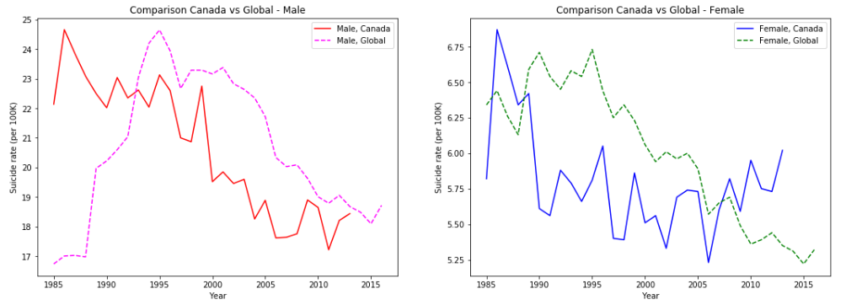

**Figure x.3 Annual suicide rate trends – Canada vs Global, Female & Male**

Figure x.3 clearly shows that Canadian suicide rates have been going down steadily since 80s for Males. This trend is in line with the global trends for males since 1995. Since mid-90s, Canada experiences lower than global suicide rates for males although Canada male suicide rates seems to be increasing and the gap between Canada and Global rates has been closing for the past few years.

For Females, similar to the trend with Males, suicide rates in the latest years are much lower in comparison to 1980s however we see that the suicide rate for females in Canada has been increasing since 2006 in contrast to the declining trend globally. Global News covered this topic specifically as part of the article linked below. Statistics Canada confirms the trend showing higher increase in suicide rates for female in comparison to male for last 15 years. There may be multiple contributors to this trend such as increasing mental health cases for women, higher number of single moms and increased pressure on women with combined work and house responsibilities along with childcare and parent-care. <https://globalnews.ca/news/4274136/suicide-rates-women-men-canada/>

**x.3 Annual % change in suicide rates – Canada vs Global**

For this analysis, we first calculated ‘annual_change’ for year-over-year suicide rate changes experienced in Canada vs Global in terms of % of previous year’s suicide rate.

# annual_change added to Grouped **Canada** dataset

C3=C1.assign(annual_change=C1.groupby('sex')['suicide_rate'].apply(lambda x:x.diff().fillna(x)));C4=C3.reset_index('sex').drop(['1985'])

# annual_change added to Grouped **Global** dataset

G3=G1.assign(annual_change=G1.groupby('sex')['suicide_rate'].apply(lambda x:x.diff().fillna(x)));G4=G3.reset_index('sex').drop(['1985'])

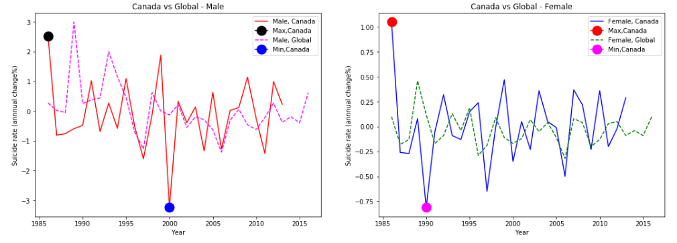

**Figure x.4 Annual change in suicide rates – Canada vs Global, Female & Male**

We see in Figure x.4 that for both Male and Female suicide rates, the **biggest annual increase** in suicide rates came **between years 1985 and 1986**. Highest decrease in suicide rates in Canada was experienced between years 1999 and 2000 for Males and between years 1989 and 1990 for Females as pointed on Figure x.4.

Based on Wikipedia page linked below, the [Canadian dollar](https://en.wikipedia.org/wiki/Canadian_dollar) hit an **all-time low** of 70.2 U.S. cents on international money markets in the beginning of **1986** which must have caused financial difficulties for Canadians and eventually meant more suicides in the country.

<https://en.wikipedia.org/wiki/1986_in_Canada>

**Y. SUICIDE RATE ANNUAL CHANGES – HIGHEST INCREASES AND DECREASES**

For this analysis, we only focused on the last 10 years and included all the countries in the analysis. First, we grouped our main master_good dataframe by year, country and sex columns and then added suicide_rate and annual_change parameters. As we decided to only focus on last 10 years, we only took the years where year value is bigger or equal to 2007.

Overall=master_good.groupby(['year','country','sex'])['suicides_no','population'].sum()

Overall['suicide_rate']=round((Overall.suicides_no/Overall.population)*100000,2)

O1=Overall.reset_index()

O2=O1.assign(annual_change=O1.groupby(['country','sex'])['suicide_rate'].apply(lambda x:x.diff().fillna(x)));O3=O2.loc[O2['year']>=2007]

**# TOP 5 countries who experienced the highest annual increase/decrease (Female)**

Overall_f=O3.loc[O3['sex']=='female'];Overall_f.sort_values('annual_change')

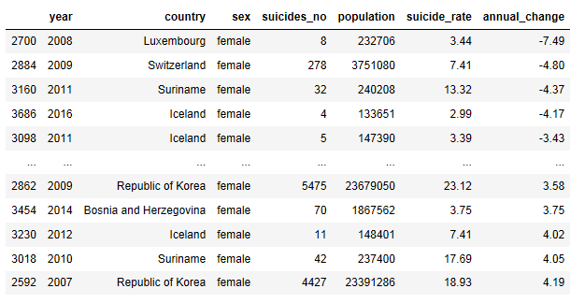

**# TOP 5 countries who experienced the highest annual increase/decrease (Male)**

Overall_m=O3.loc[O3['sex']=='male'];Overall_m.sort_values('annual_change')

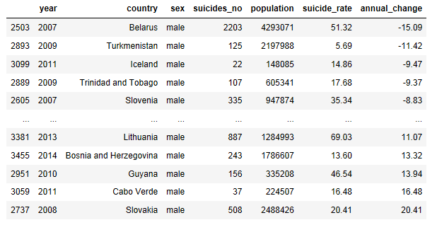

In the notebook attached, detailed graphs are shown specific to those countries with highest annual decrease and increase in suicide rates. For detailed analysis, only Iceland, Belarus and Lithuania are selected and shown below. Iceland shows up in both highest annual increase and also decrease tables for females and also shows up in Top 5 countries list with highest suicide rate decrease in one year for the last 10 years for males. Belarus and Lithuania are selected as they have significantly high suicide rates in comparison to other countries in the list.

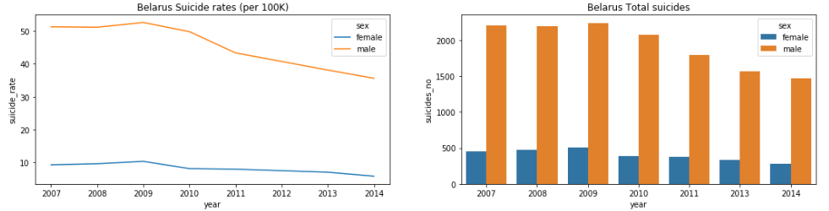

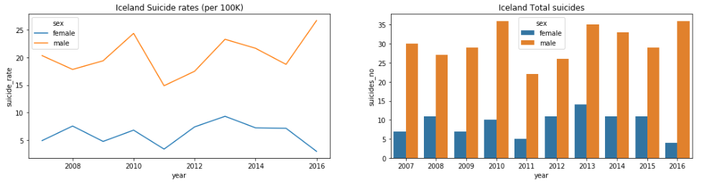

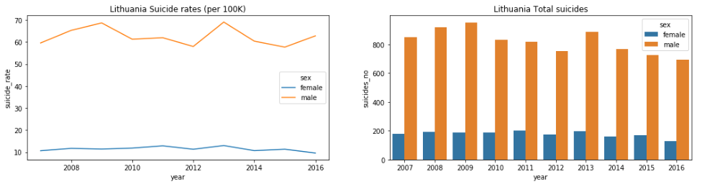

**Figure y.1 Selected countries with highest annual increase and/or decrease in suicide rates**

For Belarus suicide rates, many studies indicate that increases in alcohol consumption in the country (esp. strong spirits) correlates with an increase in number of suicides. The most famous study on this correlation was conducted by [Yury Razvodovsky](https://www.researchgate.net/profile/Yury_Razvodovsky) and is linked here:

<https://www.researchgate.net/publication/26860958_Alcohol_and_suicide_in_Belarus>

The low level of religiousness in Belarus is also claimed to affect the suicide numbers according to many. Belarus is one of the most atheistic countries worldwide. The best article on the internet that provides a comprehensive overview of suicide rates in Belarus is linked below. This article also draws attention to the similarities between Lithuania and Belarus in terms of their common history and tendencies.<https://odb-office.eu/policy-briefs/why-do-belarusians-commit-suicide>

For fluctuations in suicide rates in Iceland, there is no robust study or conclusion on the reasons. The study below again draws attention to the correlation between alcohol consumption esp. spirits vs suicide rates. This study focuses on the suicide rates in Iceland.

<https://www.researchgate.net/publication/12822048_Effect_of_changing_alcohol_laws_in_Iceland_on_suicide_rates>

Year 2011 specifically shows one of the highest annual decrease for both Male and Female suicide rates among all the countries included in the analysis. As noted in the summary linked below, in 2008, Iceland had the largest budget deficit as a share of GDP in the European region and budget deficits have remained large each year through 2011. After negative real per capita GDP growth in 2009 and 2010, Iceland's economy returned to **positive growth in 2011**. This economic situation seems to show itself in the suicide rate changes in Iceland between 2008 and 2011.

<https://www.ncbi.nlm.nih.gov/books/NBK447893/>

Please also note the detailed graphs make it visible that Bosnia H. only reported suicides for years 2011 and 2014. Similarly, Cabo Verde reported suicide statistics only for year 2011. Hence, the names of those countries are removed from the final countries_highest list due to lack of their data reporting.

countries_highest=['Belarus','Turkmenistan','Iceland','Trinidad and Tobago','Slovenia','Lithuania',~~'Bosnia and Herzegovina'~~,'Guyana',~~'Cabo Verde'~~,'Slovakia','Luxembourg','Switzerland','Suriname','Republic of Korea']